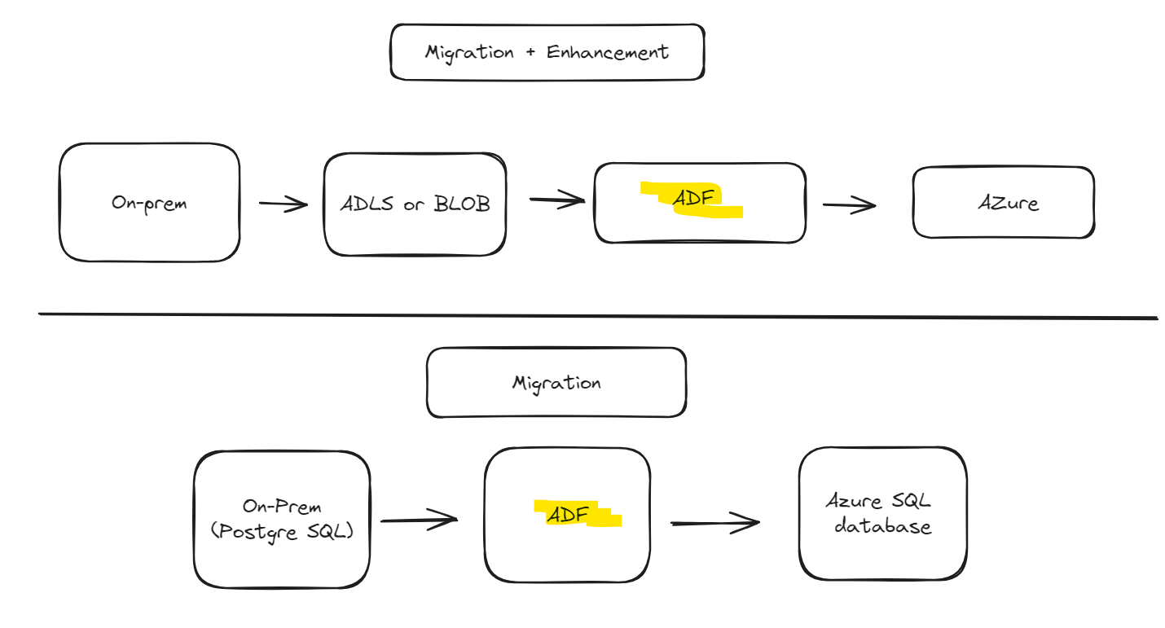

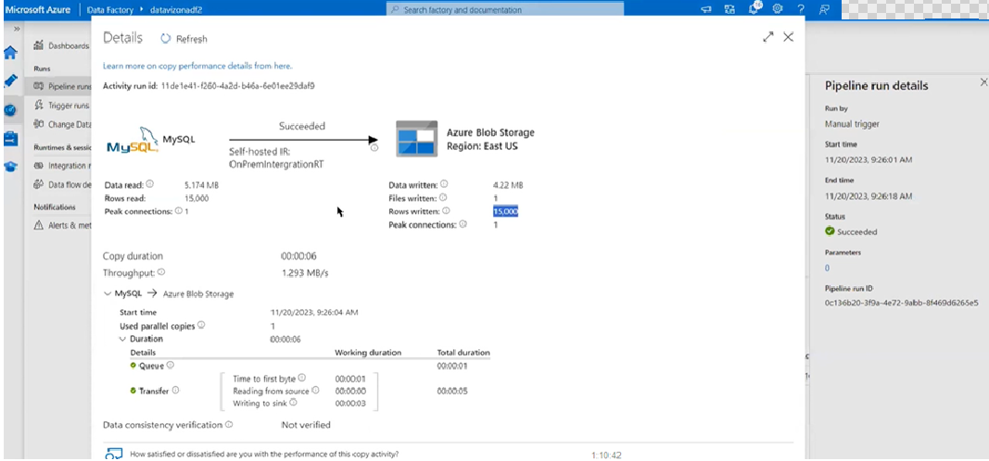

First pipeline is a migration pipeline (on-prem to blob).

The data in blob can be considered as staging data (intermediate storage), can be used for other projects/transformations which having to again migrate from on-prem.

This is a full load but in real time scenarios, we mostly use incremental load.

Using multiple files for upload to adls-gen 2:

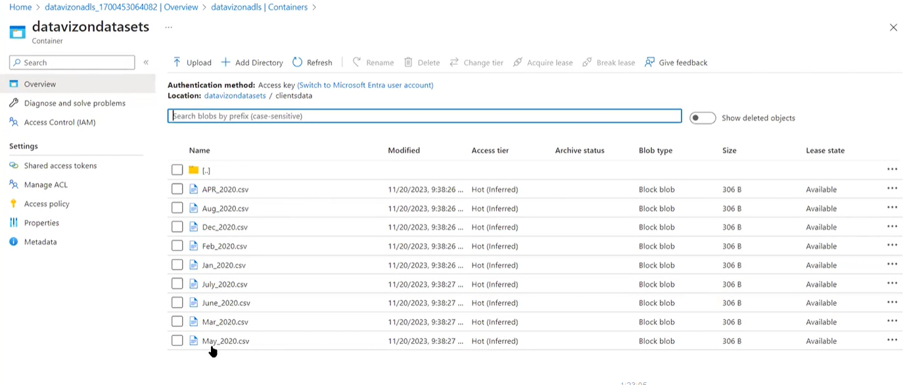

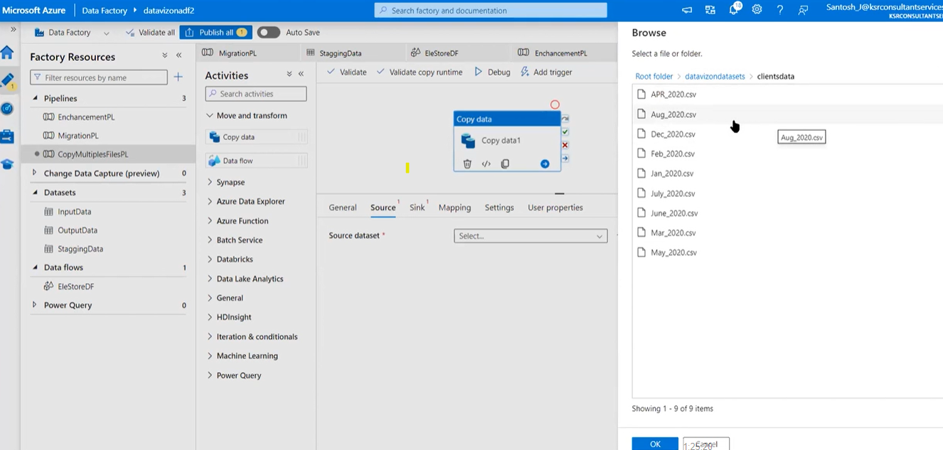

Don’t select any one particular file (as we are trying to upload all of them here) > Click OK

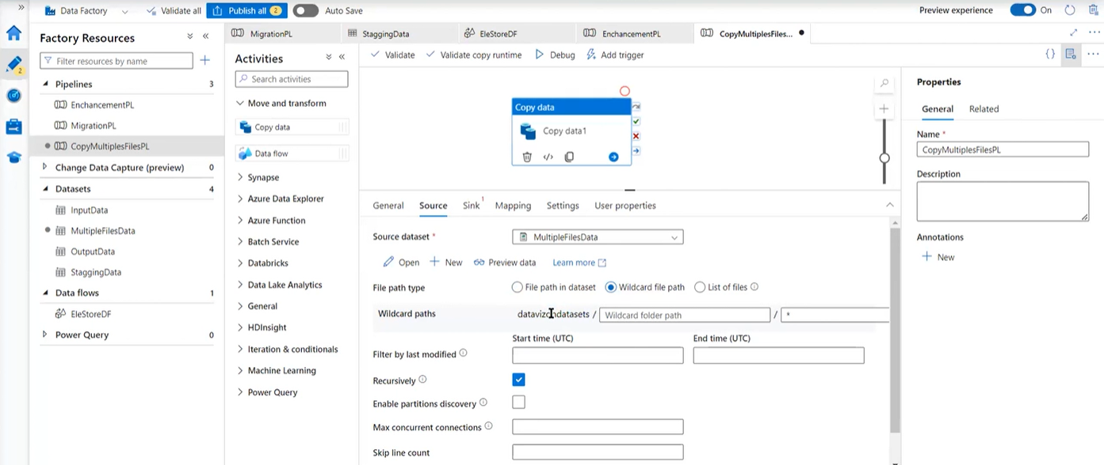

Note > File Path type : Wildcard file path

Wildcard paths > \*

For this activity, the datasets should have same format.